 |  | [INSERT YOUR LOGO HERE]
 |  | 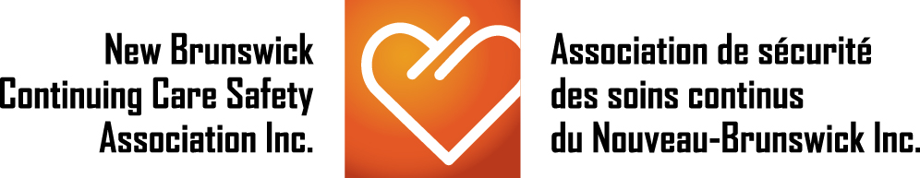
SAFETY  “We will do everything you need and want for the resident until it impacts staff safety. Once staff safety is compromised, we need to think about other solutions”  Contact  Name & Title  Goes here  PHONE:  678-555-0103  EMAIL:  someone@example.comHYPERLINK "mailto:emailgoeshere@example.com" |  | Today’s Date  Dear [NAME],  Our care staff have recently brought forward concerns regarding difficulty and discomfort when dressing [NAME OF RESIDENT]. This has prompted us to do a detailed assessment to determine the degree of change in their ability to dress.  The Adaptive Clothing Assessment Tool shows a decrease in abilities of: [choose all that apply; communication, range of motion, mobility, cooperation and/or excessive staff exertion]. Not only does this impact the comfort for [NAME OF RESIDENT], but also brings with it the risk of serious staff injuries.  Adaptive clothing is the solution to address these concerns. This type of clothing will promote comfort, ease, and safety for both [NAME OF RESIDENT] and staff. Specific styles and features can be purchased from a variety of vendors, easily located on the internet.  It would be most appreciated if you could find time between [RANGE OF DATE AND TIME] to meet with [NAME OF PERSON] to review the wardrobe and to prioritize those items that need to be purchased immediately.  [OPTIONAL PARAGRAHPH] We have access to a small supply of previously used adaptive clothing that you are free to use until you are able to purchase for [NAME OF RESIDENT].  We thank you for your continued cooperation and partnership with [NAME OF NURSING HOME] in supporting these types of solutions to enhance [NAME OF RESIDENT]’s time at the home, in a more dignified and caring manner.  Sincerely,  [NAME OF AUTHOR]  [TITLE OF AUTHOR]

